1、EasyX中画布的坐标系原点位于屏幕左上角

x

y

- 图形绘制相关函数
void circle(int x,int y,int radius)//圆心横坐标、纵坐标、半径
void rectangle(int left,int top,int right,int bottom)
//矩形左部x坐标，矩形上部y坐标
//矩形右部x坐标，矩形下部y坐标
void polygon(
const POINT *points,
int num
);//绘制多边形
参数含义：
points
每个点的坐标，数组元素个数为 num。
该函数会自动连接多边形首尾。
num
多边形顶点的个数。
以下局部代码绘制一个三角形(两种方法)：
// 方法 1
POINT pts[] = { {50, 200}, {200, 200}, {200, 50} };
polygon(pts, 3);
// 方法 2
int pts[] = {50, 200, 200, 200, 200, 50};
polygon((POINT*)pts, 3);

- 坐标计算（xstart 、ystart表示右下角参考点，wheel表示车轮半径）
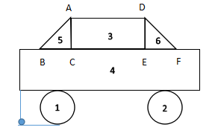
1：xstart+3.5*wheel,ystart-wheel,wheel
2：xstart+12.5*wheel,ystart-wheel,wheel
3：xstart+4.5*wheel,ystart-6*wheel,xstart+11.5*wheel,ystart-4*wheel
4：xstart,ystart-4*wheel,xstart+16*wheel,ystart-2*wheel
5： A xstart+4.5*wheel,ystart-6*wheel
B xstart+2.5*wheel,ystart-4*wheel
C xstart+4.5*wheel,ystart-4*wheel
6： D xstart+11.5*wheel,ystart-6*wheel
E xstart+11.5*wheel,ystart-4*wheel
F xstart+13.5*wheel,ystart-4*wheel

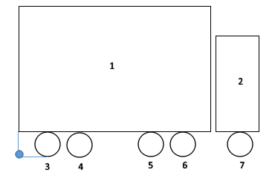

1：xstart,ystart-10*wheel,xstart+18*wheel,ystart-2*wheel
2：xstart+18*wheel+2,ystart-8*wheel,xstart+22*wheel+2,ystart-2*wheel
3：xstart+2*wheel,ystart-wheel,wheel
4：xstart+4.5*wheel,ystart-wheel,wheel
5：xstart+13.5*wheel,ystart-wheel,wheel
6：xstart+16*wheel,ystart-wheel,wheel
7：xstart+20*wheel+2,ystart-wheel,wheel

- 以Rectangle作为类名构造对象时会出错，可能出现了重名现象
- 为避免链接错误，要给类的构造函数和析构函数写上函数体
- 含有纯虚函数的类叫做抽象类，不能实体化对象
- 若创建Figure *object[6];的对象，代码不同的地方如下所示

class Figure
{
public:
virtual void move(int,int) {}
virtual void move(int,int,int,int) {}
virtual void move(int []) {}
Figure() {}
};

class Car:public Figure
{
private:
int xstart,ystart,wheel;
public:
Figure *object[6];
Car(int,int,int);
void draw();
void hide();
void move(int,int);
void clear();
};

void Car::clear()
{
int j;
for(j=0;j<6;j++)
delete(*(object+j));
}

Car::Car(int x,int y,int w)
{
*(object+0)=new Circle(xstart+3.5*wheel,ystart-wheel,wheel);
*(object+1)=new Circle(xstart+12.5*wheel,ystart-wheel,wheel);
*(object+2)=new Rect(xstart,ystart-4*wheel,xstart+16*wheel,ystart-2*wheel);
*(object+3)=new Rect(xstart+4.5*wheel,ystart-6*wheel,xstart+11.5*wheel,ystart-4*wheel);
*(object+4)=new Polygon_3(a);
*(object+5)=new Polygon_3(b);
}

void Car::draw()
{
int j;
for(j=0;j<6;j++)
object[j]->draw();
}
void Car::hide()
{
int j;
for(j=0;j<6;j++)
object[j]->hide();
}

void Car::move(int dx,int dy)
{
object[0]->hide();
object[0]->move(xstart+3.5*wheel,ystart-wheel);
object[0]->draw();
object[1]->hide();
object[1]->move(xstart+12.5*wheel,ystart-wheel);
object[1]->draw();
object[2]->hide();
object[2]->move(xstart,ystart-4*wheel,xstart+16*wheel,ystart-2*wheel);
object[2]->draw();
object[3]->hide();
object[3]->move(xstart+4.5*wheel,ystart-6*wheel,xstart+11.5*wheel,ystart-4*wheel);
object[3]->draw();
object[4]->hide();
object[4]->move(a);
object[4]->draw();
object[5]->hide();
object[5]->move(b);
object[5]->draw();
}

Van 和Car类似，不再赘述。

